Тема: Ecology Legislation in Russia and Great Britain

Автор:
Савельева Анастасия Сергеевна,
11 класс МАОУ СОШ № 213
«Открытие»
Первомайского района
города Новосибирска

Научный руководитель:
Кочеткова Ирина Вячеславовна,
учитель английского языка 1 к.к.
МАОУ СОШ № 213 «Открытие»
конт. тел. 8-913-950-15-69

Новосибирск 2018

Content
INTRODUCTION 3
1.Theoretical Part 5
1.1. Legislation in Great Britain and Russia 5
1.2. Ecology Legislation in Great Britain and Russia 7
2.Practical Part 11
2.1. Recommendations for Russian Ecology Legislation 11
2.2. Booklet Creation 12
CONCLUSION
Appendix 14
List of Information Sources 14
Appendix 1 (booklet) 15

INTRODUCTION
The third Millennium is unimaginable without the environment. Towards reducing the global environmental problems, the comparative analysis of environmental legislation of the United Kingdom of Great Britain and Northern Ireland and Russia is of practical importance .This work concerns the identification of similarities and differences of environmental legislation and is aimed at the usage of positive foreign experience in the field of ecological environment in the light of world trends and set objectives in the Russian legislative practice.
Topicality of the research is manifested in the ongoing qualitative growth of cooperation of subjects of international law. It is international-legal mechanisms of regulating the activities of States and international organizations aimed at the preservation of the ecological environment through the prevention, reduction of adverse effects on nature in the unity of the national legal measures, open the way to achieve harmony of society and nature.
There are relatively few academic works dedicated to the comparative analysis of environmental legislation of Russia and the UK . However, our country's accession to the Council of Europe, integration into the world community, increasing mutual exchange of information, including in the sphere of legal regulation of public relations in the field of environmental protection and rational use of natural resources, put forward the requirement of enhancing the mentioned developments, aimed at a comprehensive study of international environmental legislation to incorporate available positive experience in other countries.
The object of the research is legislation, measures of regulation of social relations, expressed in regulatory requirements, scientific and practical legal works, legally significant events and facts.
The subject of the research is the process of environmental protection in Russia and abroad.
Hypothesis: the UK environmental law is much better than environmental law in Russia
The aim of the study: to research the environmental laws of Russia and the UK and compare them.
To achieve the goal I set the following tasks:
1. study the legislation and laws of 2 countries
2. make a comparative analysis based on the identification of laws
3. give recommendations for improving the ecological condition of the area
4. make a recommendation booklet
Research methods:
They are theoretical and empirical.
A brief review of the literature and sources:
In conducting the study sources in the form of videos and articles posted on the Internet were opened as an informational support.

1. Theoretical Part
1.1 Legislation in Great Britain and Russia
The main legislative documents of both countries (Great Britain and Russia)are Constitutions, but they have different history and content and they also look differently.
In Great Britain there is no written Constitution, there is no law or set of laws that would officially be announced the main laws of the country. Legal Constitution of the UK includes a variety of sources, which number is impossible to establish precisely: criteria by which a particular source of law can be attributed to the constituent parts of the Constitution has not been developed neither in law nor in doctrine.The Constitution of Great Britain consists of four categories of sources: statutes, judicial precedents, constitutional customs, doctrinal sources.
A statute is an act adopted by both houses of parliament in accordance with the procedure established for this purpose. It is signed by the head of state, monarch. All laws are equally valid. In fact, many acts of the Middle Ages are not valid: their provisions are cancelled by later documents. Judicial precedent is a decision on the constitutional issues of the so-called high courts. Court decisions may be based on laws and prior judicial precedents. Court decisions may be based on moral and ethical norms that correct “unfair” legal norms. It also has constitutional norms, although they are very few. Constitutional customs are formed in the practice of the highest organs of the state. Constitutional customs are more essential than judicial precedents. Doctrinal sources are the opinions of eminent legal scholars on constitutional law. They are addressed by the Parliament and the courts in the case of gaps in constitutional regulation. The unwritten constitution of Great Britain is extremely flexible, which makes it possible to adapt it constantly and easily to changing conditions. All laws, precedents, constitutional customs have the same force. There are no special requirements to the order of changing laws. Their role, influence, strength are measured only by their authority.
The Constitutionof the Russian Federation is the basic law of the state, a special regulatory legal act. It has the highest legal force. The Constitution defines the foundations of the political, legal and economic systems of the state. The Constitution was adopted by the people of Russia on December 12, 1993. The constitution has the highest legal force, which establishes the foundations of the constitutional system of Russia, the state structure, the formation of representative, executive, judicial authorities and the system of local self-government, human and civil rights and freedoms, and constitutional amendments and revision of the Constitution. This document provides a quick resolution of so many problems in politics, economics, social sphere, a normal life for every citizen. Much depends on how correctly and accurately every citizen implements its provisions, how we organize our life in accordance with the provisions of the Constitution. Today this document fully meets the standards of constitutionalism prevailing in the world at the turn of the century. It contains social guidelines that allow building the life of Russians. The Constitution consists of 2 parts: the first one includes the Constitution itself, it has 9 chapters; the second one includes appendices.Amendments to chapters come into force after their approval by legislative bodies of at least two thirds of the subjects of the Russian Federation.
In conclusion I would like to say that the main difference of two countries’ legislation is that one of them (Russian) is written and another one (British) is unwritten.

1.2 Ecology Legislation in Great Britain and Russia
Nowadays ecology in the world is deteriorating due to human activity. The level of air pollution, water and soil increases. One way to deal with this global problem is environmental legislation.
The main legislative acts regulating legal relations in the field of ecology in Russia are reflected in the second chapter of the Constitution of the Russian Federation. This chapter is called “Fundamentals of Environmental Management”. It defines the powers of local governments in the field of relations related to environmental protection. Many laws, codes and orders dedicated to environmental protection are created at every level (federal, regional, local, local, etc.). The main one is Federal Law on Environmental Protection. The Constitution of the Russian Federation tells that everyone has the right to a favorable environment, everyone is obliged to preserve nature, take care of the natural resources that are the basis of development, life and activities of people living in the Russian Federation. These Federal Laws define the legal basis of state policy in the field of environmental protection, ensuring a balanced solution of socio-economic problems, preserving a favorable environment, biodiversity and natural resources in order to meet the needs of current and future generations, strengthening the rule of law in the field of environmental protection and ensuring environmental safety. Federal Laws regulate relations in the sphere of interaction between society and nature. Federal Law on Production and Consumption Wastes defines the legal framework for the treatment of industrial and consumer waste in order to prevent the harmful effects of industrial and consumer waste on human health and the environment, as well as to involve such waste in economic circulation as additional sources of raw materials.Federal law on the protection of atmospheric air establishes the legal basis for the protection of atmospheric air and is aimed at the realization of the constitutional rights of citizens to a favorable environment and reliable information about its condition. Federal law on environmental impact assessment regulates relations in the field of environmental impact assessment, aimed at implementing the constitutional right of citizens of the Russian Federation to a favorable environment by preventing the negative impacts of economic and other activities on the environment.
Today in Russia there are also such environment controlling organizations as the Ministry of Natural Resources and the Environment of the Russian Federation, Rosprirodnadzor and Rostekhnadzor. They monitor the environmental situation. The Ministry of Natural Resources carries out state administration in the field of environmental management, develops federal laws to the Russian government. Rosprirodnadzor is responsible for the environmental safety of forests, nature reserves, river resources, keeps state records of objects that have a negative impact on the environment and harmful effects on the atmospheric air. Rostekhnadzor, in its turn, is responsible for industrial and infrastructural facilities and monitors compliance with technical regulations.
Environmental law is a term that is used in the UK and includes a wide range of legislation of environmental control. Some laws are very narrow and concern only one problem or activity - for example, the Mobile Homes Act 1983. In recent years, many old laws have been consolidated into large and large-scale laws. Two very important examples are the 1990 Law on Environmental Protection and the 1995 Law on the Environment. They replaced and changed many previous environmental laws. In addition, groups such as Greenpeace and Friends of the Earth are constantly imposing environmental issues on the media. In the European Union, environmental legislation is a priority, and the UK was forced to take it seriously through a series of European Union directives. Environmental law is contained in the UK national law, the European Union law, and international law. There is a wide range of tools available to ensure compliance with environmental legislation. Criminal prosecution may impose a fine or imprisonment. Licenses or contracts may regulate and set standards. For example, the Environmental Protection Agency is responsible for issuing discharge permits for companies that want to dump waste into rivers. Law enforcement agencies (such as the Environmental Protection Agency) have broad powers to inspect, report and take action on pollution. Recently, new and potentially very effective approaches to environmental legislation have been developed. The introduction of integrated pollution control sets standards for products and processes, not for discharges or emissions. The growth of eco-labeling has helped inform consumers about the environmental impact of the products they buy.Using taxation instead of legal sanctions to reduce damage to the environment is not new, but is seriously considered. For example, the use of a carbon (energy) tax to reduce and improve the efficiency of fossil fuel use may be much more efficient than legal sanctions.
Some examples of important legislation are: Environmental Permits Rules 2010, Water Act 1991, Water Act 1991, Climate Change Act 2008.
The main regulatory bodies that enforce environmental and climate change regulations in various parts of the United Kingdom are:
• Environmental Protection Agency in England;
• The natural resources of Wales in Wales;
• Scottish Environmental Protection Agency in Scotland;
• The Northern Ireland Environmental Protection Agency in Northern Ireland.
These agencies regulate the main industries and waste management, the treatment of polluted land, the quality of water and natural resources.
Certain responsibilities for environmental protection are the responsibility of local authorities, including the collection and disposal of municipal waste and the regulation of emissions from small industrial enterprises in their local area to air, water and land.
Thus, we compared ecology laws of two countries. It was difficult to find information on environmental law of the UK because it is not included into its Constitution.
2. Practical part
2.1. Recommendations for Russian Ecology Legislation
On the basis of the theoretical material presented in the first part, it is possible to single out the main recommendations for the Russian environmental legislation with the aim of creating a booklet.
1.To set rubbish bins in shorter distance from each other (especially near entrances);
2. To remove factories beyond the limits of the cities;
3. To set up the equipment, which will make less harm to nature, at factories;
4. To divide garbage into types: glass, paper;
5. To use selfdegradable plastic;
6. To increase fines for ecological crimes;
7. To make control for committing ecocrimes tougher;
8. To attract people to volunteer work;
9. To develop ecological good manners in younger generations;
10. To increase the number of cleaning days (so-called Subbotnik);
11. To make special areas for dog/cat-walking.

2.2 Booklet Creation
The booklet is realised as a brochure with a description of recommendations for the protection of Russian ecology. The form of the booklet is a modern method of presenting information. In this case, the illustrations for each recommendation represent a clarity method. To create a booklet was used thermopletter.

CONCLUSION
Based on the results of the study, the following conclusions were made:
1. The hypothesis of our research was not confirmed, Great Britain is a country with a more polluted environment than Russia
2. Comparison of laws was not easy, there is a constitution in the Russian Federation, which sets out a code of laws, and there is no such constitution in Great Britain, it's unwritten. But many regulation acts on environment are same in both countries.
3. The product of the study is “recommendations for resolving environmental issues in relation to the ecology situation in Russia”
I believe that this study has prospects as a textbook for students. This material can be supplemented with the modernization and the emergence of new ways to protect the environment.

LIST OF INFORMATION SOURCES
1.http://www.consultant.ru/popular/ (11.12.18)
2.http://www.english4u.ru/safety/zakony-soedinennogo-korolevstva.php(01.12.18)
3.https://ru.wikipedia.org/wiki/%D0%97%D0%B0%D0%BA%D0%BE%D0%BD (21.11.18)
4.http://arbir.ru/articles/a_3412.htm(15.11.18)
5.https://ecoportal.info/problemy-ekologii-v-rossii/ (02.10.18)



recommendations for the ecology protection in Russia



- set rubbish bins in shorter distance from each other (especially near entrances)


  - 2. remove factories beyond the limits of the cities


3.divide garbage into types: glass, paper, plastic

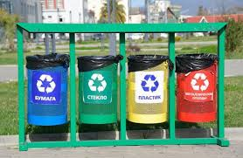
4. set up less harmful equipment at factories
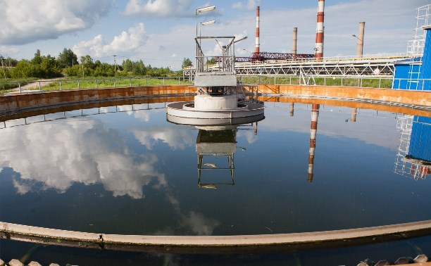

  - 5. use selfdegradable plastic
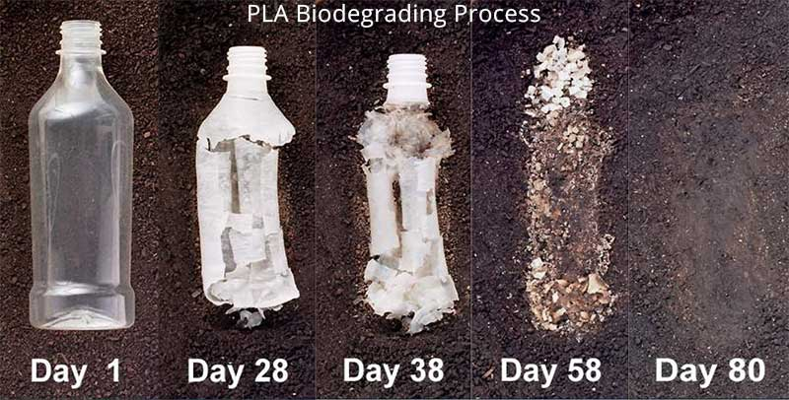
  - 6. make tougher control for committing ecocrimes

  - 7.increase fines for ecological crimes


  - 8. develop ecological good manners in younger generations
  - 
9. attract people to volunteer work

  - 10. make special areas for dog/cat-walking
  - 

11.INCREASE THE NUMBER OF CLEANING DAYS (SO-CALLED SUBBOTNIK)


