SOME INTERESTING FACTS ABOUT RUSSIA
Moscow is the biggest city in Russia. Also, Moscow is the capital of Russia. | 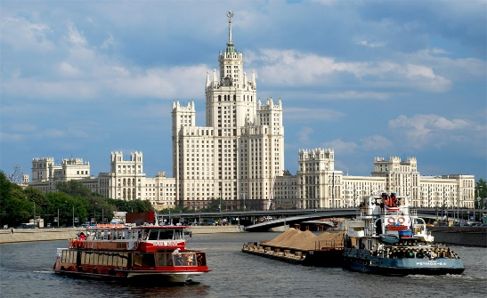
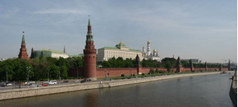 | Moscow, also has the Kremlin, this is the official residence of the president of the Russian Federation. It is located on Borovitsky Hill.
I live in Kamchatka, it is in the Far East of Russia. Giant volcanoes in Kamchatka are a real attraction. The height of the largest volcano there, the Kluchevskoy volcano, is 4,750 meters above the sea level. | 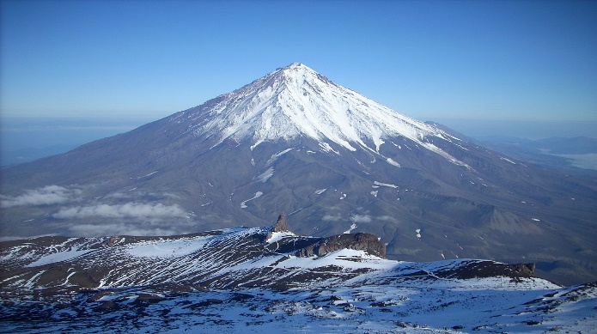
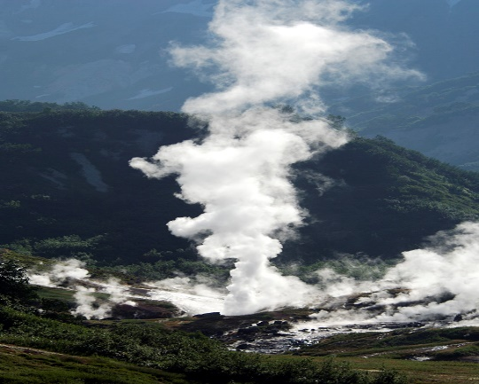 | The valley of geysers in Kamchatka is another attraction. This is the only geyser field in Eurasia. There are many things there: waterfalls, lakes, mud pots, hot springs, geysers. It is so beautiful!
In Russia, everyone plays hockey, this is our favorite game. People come from all cities of Russia to support their favorite players. At the hockey championships – our fans are the best! | 