Технологическая карта урока
Тема урока: «Volunteers» / «Волонтеры»
Тип урока: комбинированный
Цель урока:
актуализация ранее изученного лексического материала по теме «Countries and nationalities» и ознакомление с новым материалом по теме «Volunteers», грамматический материал: притяжательный падеж существительных, употребление в речи Present Simple, to be going to.
Задачи:
• развивать мотивацию и повышать интерес к изучению английского языка;
• развивать умение работать в сотрудничестве;
• повторять и активизировать лексический материал предыдущих уроков;
• открыть для себя новую общественно-полезную сферу деятельности;
• узнать суть данной работы.
Используемые приемы, методы, образовательные технологии
1.Технология: диалог культур (путь к формированию диалогового, креативного мышления)
2.Технологии повторения
3.Игровые технологии
Развитие ключевых компетенций учащихся:
Личностные: формирование ответственного отношения к учению; формирование коммуникативной компетентности в общении.
Регулятивные: осуществление самонаблюдения, самоконтроля, самооценки в процессе коммуникативной деятельности на иностранном языке.
Познавательные: развитие способности строить логическое устное высказывание по теме; освоение чтения с целью извлечения определенной информации.
Коммуникативные: развитие умения высказывать свою точку зрения, развитие способности к совместной деятельности, развитие умений адекватно использовать речевые средства для решения коммуникативной задачи

Этапы | Ход урока
Этапы | Деятельность учителя | Деятельность учащихся
Организационный этап  Цель: создание благоприятного настроя на урок  Целеполагание, мотивация. | Hello everybody! I’m glad to see  you and to meet you.  Slide 2. And I’d like to you:  - Not to be afraid me  - Don’t sleep  - Be active  Do you agree?  Are you ready to work?  How are you today?  Let’s begin our lesson  Slide 3. Look at the pictures and tell me  what are these people doing?  Right!  Who are they? What kind of job is it?  Slide 4. You must choose the correct definitions of the word ‘volunteer’  Slide 5. There are different kinds of volunteers:  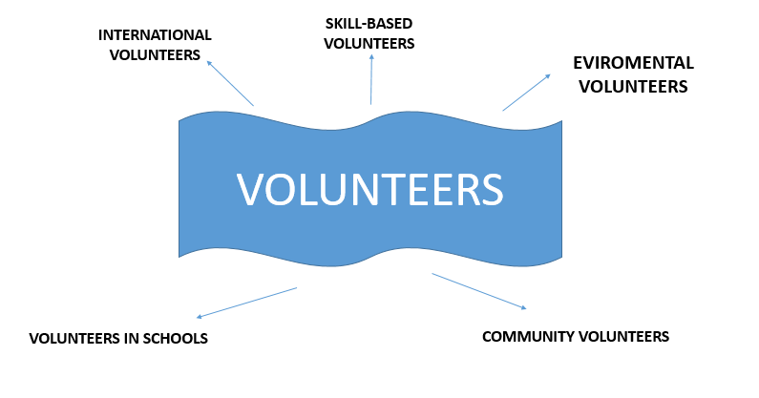 | Hello dear teacher!  We are glad to see you.  Yes, we do.  Yes, we are.  I’m OK/good/fine/tired/sleepy.  - They help old people  - Work with children  - Plant trees  - Take part in big sport festivals or events  They are volunteers.  - Someone who works not for money.  - Someone who does something because he/ she wants to.
Активизация  материала.  Ознакомление с новой лексикой. | Tell me please what volunteers help people at the big international events or festivals?  Is this topic interesting for you?  You know people who are volunteers, don’t you?  Today you try to be volunteers.  First of all look at the screen:  to be a volunteer – быть волонтером  to make friends – подружиться  to have a chat – поболтать  to take part – принимать участие  events – события  to get knowledge – получать знания  to practice skills – практиковать навыки  useful – полезный  to spend free time – проводить свободное время  to be sucessful – быть успешным  These word help us at the lesson.  First of all, do you know the symbols of volunteers?  Look at me, what is it? – a hand  A volunteering symbol is a hand | International volunteers!  Yes, it is.  Read and translate new words and phrases.
Основной этап  Целеполагание | So, today like a symbol of volunteering and the topic of our lesson let’s «high five»  I prepare for you volunteers cards, open them and you can see different flags.  International volunteers work in different countries, now it’s time to make the teams.  1st group – Asia  2nd group – Europa  High five to members of your team.  Slide 6. What is it?  You can see teenagers from different countries. Let’s say where are they from and what are their nationalities? | Pupils take cards and make their teams.  It’s a map.  Students make up sentences.
Включение нового знания в систему знаний | You’ve got cards on your desks. Turn over them.  What do the volunteers do? Is it right or wrong?  - Plant trees, flowers  - Spend money  - Clean up a pond (river, lake)  - Fight  - Look after animals  - Cook  - Donate - жертвовать (money, things)  - Ride a bike  - Take part at the sport events, festivals  - Help people  - Dance  - Work with children  - Represent the country  - Work in the team | - Plant trees, flowers  - Clean up a pond (river, lake)  - Look after animals  - Donate - жертвовать (money, things)  - Take part at the sport events, festivals  - Help people  - Work with children  - Represent the country  - Work in the team
Применение учебного материала в знакомой и новой учебной ситуации. | Be going to  Are you going to be a volunteer?  What are you going to do? | Yes, I am.  I’m going to help old people at the hospitals.  I’m going to look after animals.
 | Slide 7. Listening.  Being a volunteer is one of the best things you can do with your life. It’s a great way to help other people. It’s also very satisfying to know that you are not wasting your time and are helping people who need help. So many volunteer organizations need extra hands. It really is easy. I think too many of us settle into a lazy lifestyle. We just want to come home and watch TV. Life is much more interesting when you’re a volunteer. | LISTENING GAP FILL  Being __________ is one of the best things you can do with your life. It’s a great way _____ other people. It’s also very satisfying to know that you are not wasting your time and are helping people who _________. So many volunteer organizations need extra _______. It really is _____. I think too many of us settle into a lazy _______. We just want to come home and watch TV. Life is much more ___________when you’re a volunteer.
Физкультминутка | I think you’re little bit tired. Do you like to sing?  Are you sure in our Russian football team?  Song time  We are the champions  We are the champions - my friend  And we'll keep on fighting till the end  We are the champions  We are the champions  No time for losers  Cause we are the champions of the world | We are the champions  We are the champions - my friend  And we'll keep on fighting till the end  We are the champions  We are the champions  No time for losers  Cause we are the champions of the world
Применение учебного материала в знакомой и новой учебной ситуации. | Slide 8.  What is the symbol of FIFA world cup?  What volunteers can do at this event? | Zabivaka  They can tell and show the way.  They can help at the airport and at the hotel.
 | I’ve got a pen friend. She’s going to take part in this great event. And yesterday I got a letter from her. Let’s read it!  Hello Elizabeth!  Thank you for your letter. I’m so happy to take part in a such great event. I’m going to work as a volunteer during FIFA world cup in Moscow.  It will be my first experience in organizing the sport event. I’m going to work at the stadium to help visitors and answer their questions. I choose this kind of volunteer activities because all tourists know English and I know English too. We have big, friendly and international team. Are you going to be a volunteer?  I've to go as my mum is asking me to help her with her dinner.  Write back soon.  Best wishes, Kate | Hello Elizabeth!  Thank you for your letter. I’m so happy to take part in a such great event. I’m going to work as a volunteer during FIFA world cup in Moscow.  It will be my first experience in organizing the sport event. I’m going to work at the stadium to help visitors and answer their questions. I choose this kind of volunteer activities because all tourists know English and I know English too. We have big, friendly and international team. Are you going to be a volunteer?  I've to go as my mum is asking me to help her with her dinner.  Write back soon.  Best wishes,  Kate
 | True or False.  - Kate’s going to be a volunteer in Samara.  - She doesn’t like her job.  - Kate was a volunteer earlier.  - She can speak English.  - Kate’s team will work at the hotel.  - She has to help her mum. | True or False.  - Kate’s going to be a volunteer in Samara. - False  - She doesn’t like her job. - False  - Kate was a volunteer earlier. - False  - She can speak English. -True  - Kate’s team will work at the hotel. - False  - She has to help her mum. - True
Thanks a lot! Now it's time to check your knowledge. Look at the screen. The task is to match the word phrases with their translation.
1) to take money | a) давать интервью
2) to spend free time | b) принимать участие
3) useful | c) проводить свободное время
4) to take part | d) стать знаменитым
5) to become famous | e) подружиться
6) responsible | f) брать деньги
7) to give interview | g) ответственный
8) to practice skills | h) быть волонтером
9) to make friends | i) полезный
10) to be a volunteer | j) практиковать навыки

Project work | Now you are going to design a poster to support young people to do voluntary work. You should think of a motto or a heading for the poster. You could display them around your class. | Pupils make posters then show them to the class.
Рефлексия | You have done a good job of it! Now you know a lot about volunteers. You all worked hard!  Pupils stand up and go to the blackboard, you should draw a hand like me and write a sentence about our lesson.  Your marks are …  Your homework: find information about famous volunteers or popular volunteer organization in the world.  Thank you for the lesson.  Our lesson is over. | I can make up sentences.  I can work in a team.  I can sing English songs.  I’ve learnt countries and nationalities.  It was interesting to know about volunteer activity.  It was interesting to know about types of volunteering.  Now I’ve knew what volunteers do.

